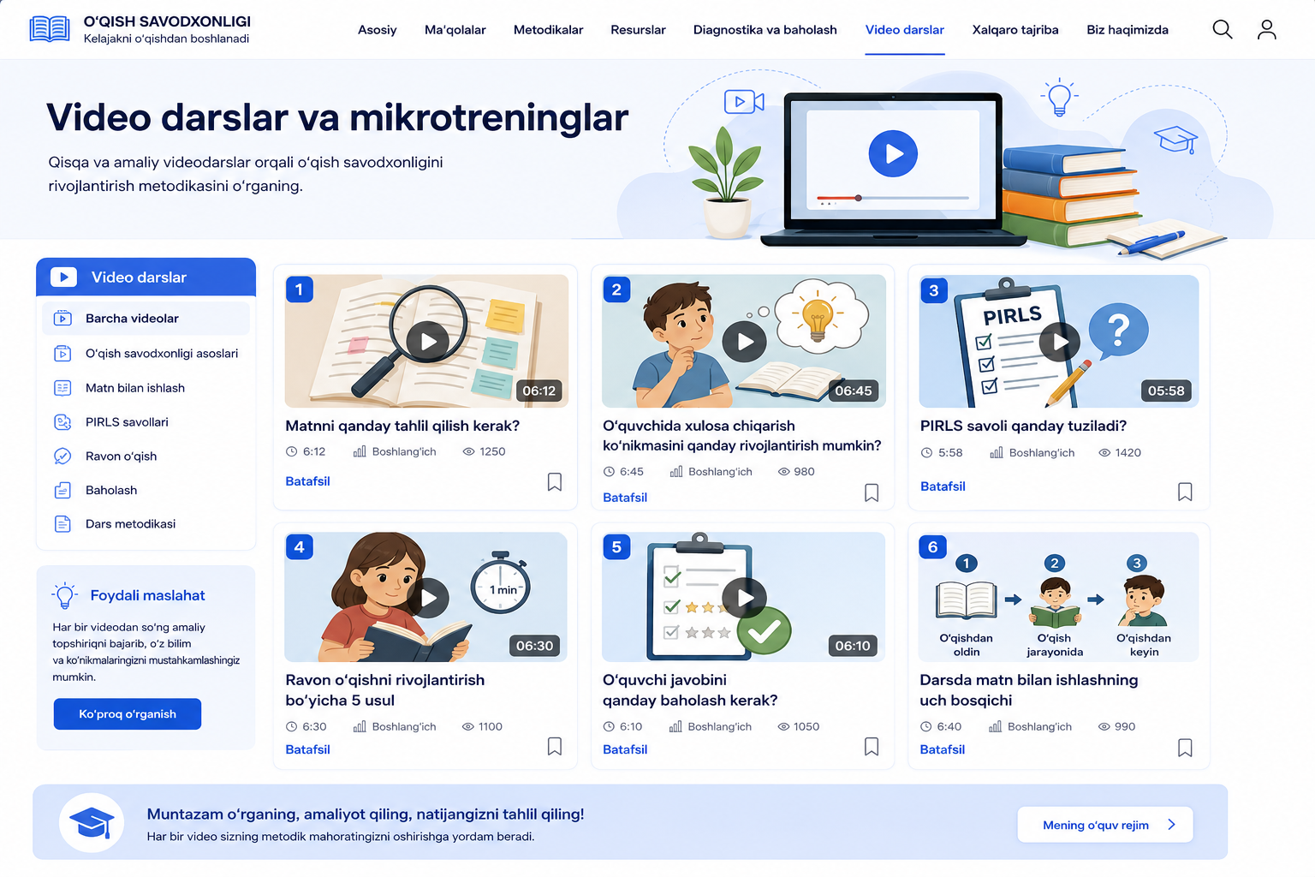

Video linkalari:
1. https://www.youtube.com/watch?v=R2PJHB81OHg
2. https://www.youtube.com/watch?v=lTo-m7Ud6UA
2. https://www.youtube.com/watch?v=IcIHPdDhSXU
3. https://www.youtube.com/watch?v=mZdYpsoXz1g
4. https://www.youtube.com/watch?v=SUpNlfP1wHw
5. https://www.youtube.com/watch?v=r4h0z0wS_UU
6. https://www.youtube.com/watch?v=FZsmPfQX6Gc
7. https://www.youtube.com/watch?v=qGfnc4q-jTo
8. https://www.youtube.com/watch?v=F1p-Yp92QB0
9. https://www.youtube.com/watch?v=oH2TmwLXVos
10. https://www.youtube.com/watch?v=hVL5PZyK2Ec
11. https://www.facebook.com/100026621564775/videos/sehrli-soz-1-qism2-sinfoqish-savodxonligi/1255572873411989/

